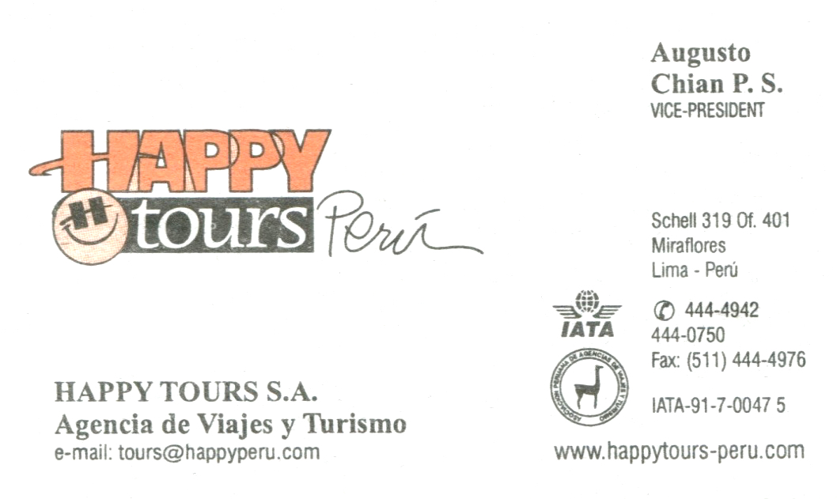
ARCHAEOLOGY, CULTURAL HERITAGE AND SUSTAINABLE DEVELOPMENT
IN THE LAND OF THE INCAS (PERU)

ITINERARY IN PERU: MAY 18-28, 2023
with Happy Tours Director, Augusto Chian and Valentin Quispe, local Cuzco guide

THURS, MAY 18: FLY TO PERU (the reason for this date is to have Saturday, May 27 with no traffic for our visit to the historic center of Lima)
DAYTIME FLIGHT CHICAGO-MIAMI-LIMA OR CHICAGO-DALLAS-LIMA,
arrive very late that night
Happy Tours meets us in Lima airport and transfers us to Miraflores hotel
overnight: Hotel La Hacienda

F, MAY 19
- BREAKFAST at hotel (dining room closes at 9:30 a.m.).
- Orientation in situ.
- LUNCH: MANGOS in LARCO MAR
- Visit LUM (Lugar de la Memoria: museum about Peru’s Civil War)
- Visit Barranco, the once seaside district and discuss gentrification and urban change
- In hotel lounge: Discussion with Augusto of contemporary Peruvian political situation.
- dinner on their own
overnight: Hotel La Hacienda

SAT, MAY 20
- BREAKFAST at hotel.
- Morning: fly to Cuzco on LATAM
- check in at hotel
- rest for two hours
- LUNCH: MORENA
- change money
- walking tour of historic center of Cuzco: Inca occupation, Colonial overlay, extensive challenges of the World Heritage Site
- dinner on their own
overnight: Hotel Los Apus

SUN, MAY 21
- BREAKFAST at hotel.
- Morning: Inca sites of Sacsayhuaman-Tambo Machay-Kenko
- LUNCH: CASA CORICANCHA RESTAURANT
- Afternoon: Inca Temple of the Sun. Cathedral. Discuss the two identities of Cuzco: Inca and Spanish.
- Optional visit to San Pedro Market with Helaine
- dinner on their own
overnight: Hotel Los Apus

MON, MAY 22
- BREAKFAST at hotel.
- All day trip through the Sacred Valley: Chinchero, Maras, Moray, Sra. Mercedes’ Descanso de Aja (chicha).
- LUNCH: TUNUPA IN URUBAMBA
- Arrive in Ollantaytambo. Check in. Tour the contemporary occupied Inca town.
- DINNER: HOTEL PACARIQTAMBO RESTAURANT
overnight: Hotel Pacariqtambo

TUES, MAY 23
- BREAKFAST at hotel.
- Vistadome train to Machu Picchu
- Check in at hotel
- LUNCH: MAPI RESTAURANT
- Bus up to ruin
- Machu Picchu World Heritage Site.
- Bus down to town. Stop at hotel to refresh.
- Walking tour of chaotic Machu Picchu Pueblo (the town) and discussion.
- dinner on the their own
overnight: Machu Picchu

W, MAY 24
- BREAKFAST at hotel.
- Expedition train back to Ollantaytambo
- LUNCH: EL ALBUERGUE
- Tour the great ruins of Ollantaytambo
- Return to Cuzco in our private bus.
- dinner on their own
overnight: Hotel Los Apus

THURS, MAY 25
- BREAKFAST at hotel.
- Early flight back to Lima
- lunch on their own – suggest La Sangucheria or the like
- Then walking tour of Miraflores with Helaine en route to see pre-Inca site of Huaca Pucllana and discuss it in the context of its fancy restaurant as a development project.
- Stop at Helados 4D for gelato en route back to hotel
- At hotel: discussion
- dinner on their own
overnight: Hotel La Hacienda

F, MAY 26
- BREAKFAST at hotel
- MALI/Museo de Arte OR Presbitero Maestro Cemetery
- LUNCH: Surquillo market followed by cooking class: food, culture and society in Peru
- Optional visit to nearby “Indian Market”
- dinner on their own
- overnight: Hotel La Hacienda

SATURDAY, MAY 27
- BREAKFAST at hotel.
- Historic Center of Lima. Include visit Convento de San Francisco with catacombs (ticket).
- Late lunch on their own
- Depart hotel at 6 p.m. for overnight flight back to U.S.
- KEEP ROOMS AT LA HACIENDA UNTIL 6 P.M.

SUNDAY, MAY 28: arrive in Chicago – students go to their homes

