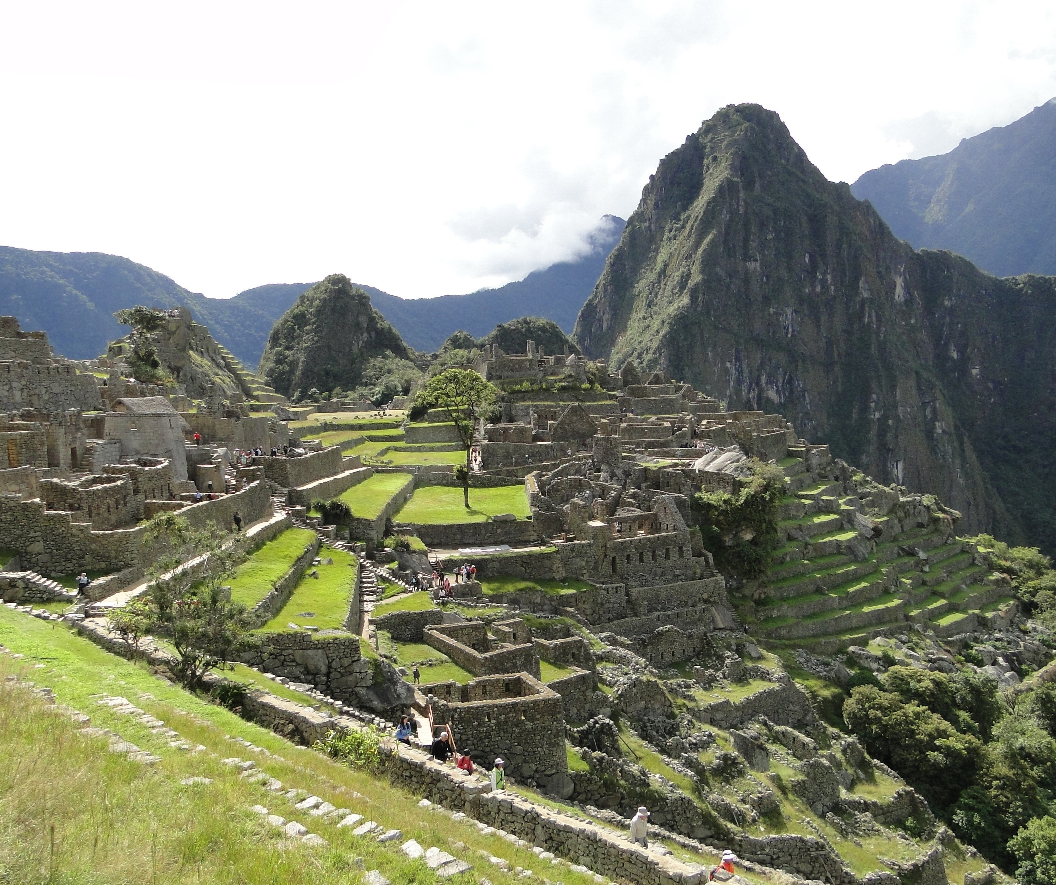Intercultural Study Tour

May 18 - 28, 2023

ANTH 209 (3 credits)

Archaeology, Cultural Heritage, and Sustainable Development in the Land of the Incas
Prof. Helaine Silverman

For academic information and Peru details contact Professor Silverman at helaine@illinois.edu

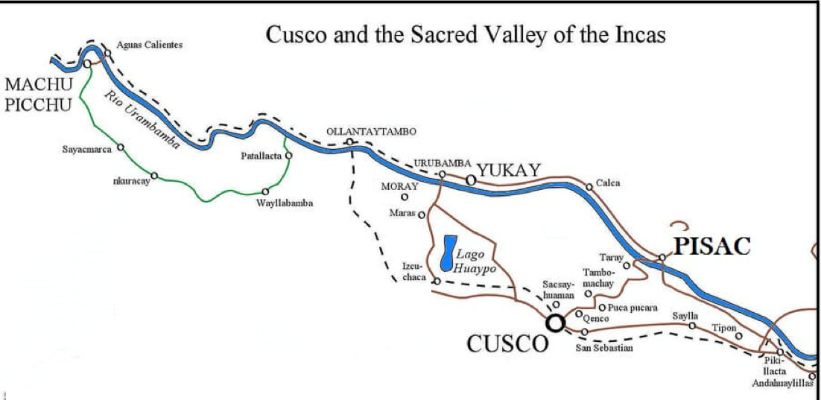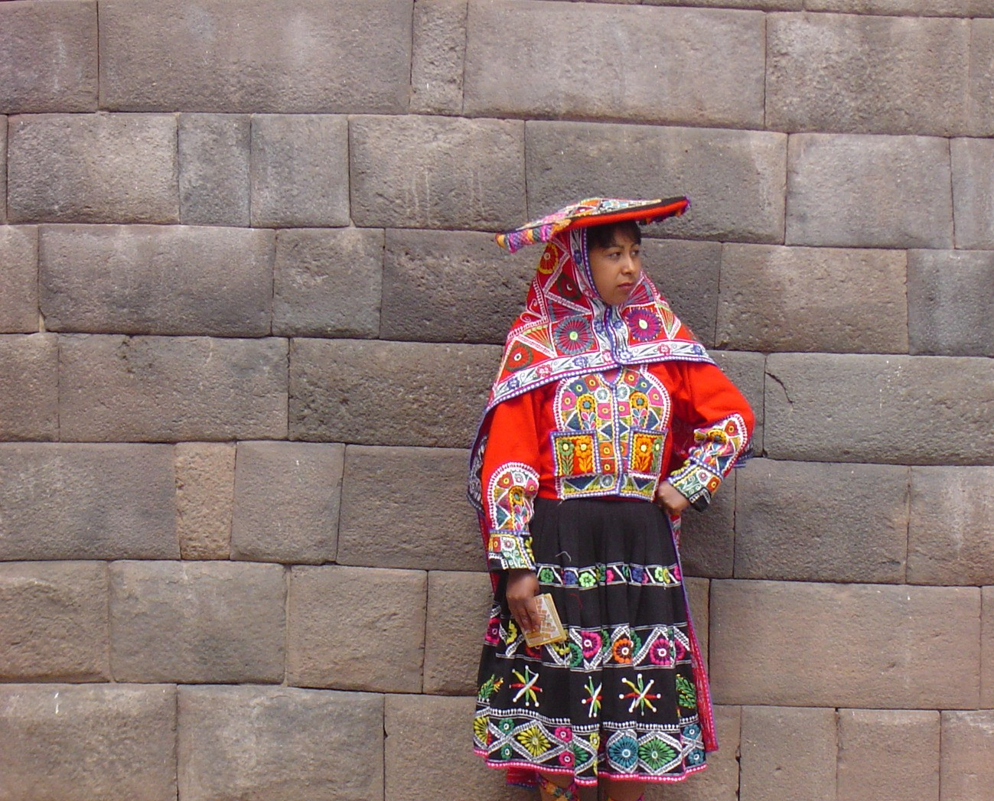
Estimated Program Fee: $4,000
Includes international + domestic airfare, hotels, local transportation, activities, + most meals

Join Professor Helaine Silverman (Anthropology) on this thrilling exploration of the heartland of the ancient Inca Empire. See its heritage expressed by the descendants of that great Andean society. Fly over the snow-capped Andes mountains. Visit spectacular Inca ruins, including the renowned “lost city” of Machu Picchu. Travel on one of the most scenic train rides in the world. See the beautiful colonial churches built by the Spanish conquerors in Cuzco, the former Inca capital and today the epicenter of global tourism. Learn about the politics and policies of tourism and heritage management that promote economic development in this stunning highland region. Sample the delicious cuisine of Peru, which has achieved global acclaim. Stay in unique hotels. Participate in many interactions with local people. Finish the trip with two fascinating days in Peru's capital city, Lima, where we continue our time-travel through the heritage and economic development of the pre-Columbian, colonial and modern city.
Enjoy a special tour of the UNESCO-designated historic center and a full day at
a restored hacienda. Professor Silverman spent the first half of her adult life in Peru as an archaeologist and since then has conducted more than ten years of contemporary research in Cuzco. This study-abroad experience offers an insider's view of the country. Your preparation for Peru begins on campus with the preparatory information sessionsdesigned to give you the historical and cultural background knowledge necessary to make the most of your Peru experience.
Then the educational adventure continues in Peru.

