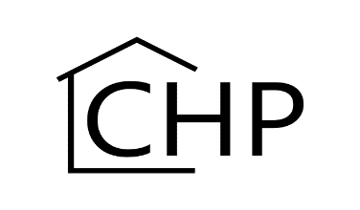

CHP Course Request for Non-Campus Honors Program Students

The following student wishes to take a course offered by the Campus Honors Program (CHP).

The CHP will attempt to accommodate requests from non-CHP students as long as enrollment limitations permit and there are sufficient spaces for CHP students.

Please email the completed form to chp@illinois.edu or deliver to the Campus Honors Program at 1205 W Oregon St., Urbana, IL 61801.

Student Information

Name: Click or tap here to enter text. Email: Click or tap here to enter text.
UIN: Click or tap here to enter text.
Cumulative GPA: Click or tap here to enter text.
College and Major (if known): Click or tap here to enter text.

Course Requested

Name: Click or tap here to enter text. Course Number: Click or tap here to enter text.
Department: Click or tap here to enter text. Section:
CRN: Instructor:
Semester and Year Course is being offered: Click or tap here to enter text.

Briefly describe why you wish to take this course.

